ECC / PMG SUPPLY CHAIN INTELLIGENCE
The Cost of Not Knowing
Real Incidents. Documented Financial Losses. The Supply Chain Visibility Gap That Caused Every One.
Supplementary Research Document — May 2026 | For Sales & Marketing Use | All figures sourced from company disclosures, congressional reports, and CBP data

This document presents six documented incidents in which major companies suffered significant financial losses due to insufficient supply chain visibility — specifically the inability to trace material origin and content below Tier 1. Each incident involves either a UFLPA forced labor enforcement action or a Section 301/232/IEEPA tariff misclassification exposure. The root cause in every case is the same.

The shared root cause: Standard supply chain tools show who your suppliers are. They cannot show what your suppliers' products contain at the material level, the HS code level, or the origin level. Every incident in this document was preventable with sub-tier material genealogy intelligence.

Part 1 — The Enforcement Environment: Scale, Trajectory, and Acceleration

The incidents in this document are not outliers. They are early indicators of an enforcement regime expanding rapidly in scope, scale, and financial consequence.

1.1 UFLPA Enforcement — Year by Year

86%  Automotive share of UFLPA detentions  H1 2025 — up from 4% in all of 2024 | $3.94B  Total shipment value detained under UFLPA  since June 2022 (CBP Dashboard 2026) | 6,636  Shipments detained in H1 2025 alone —  more than all of FY2024 combined

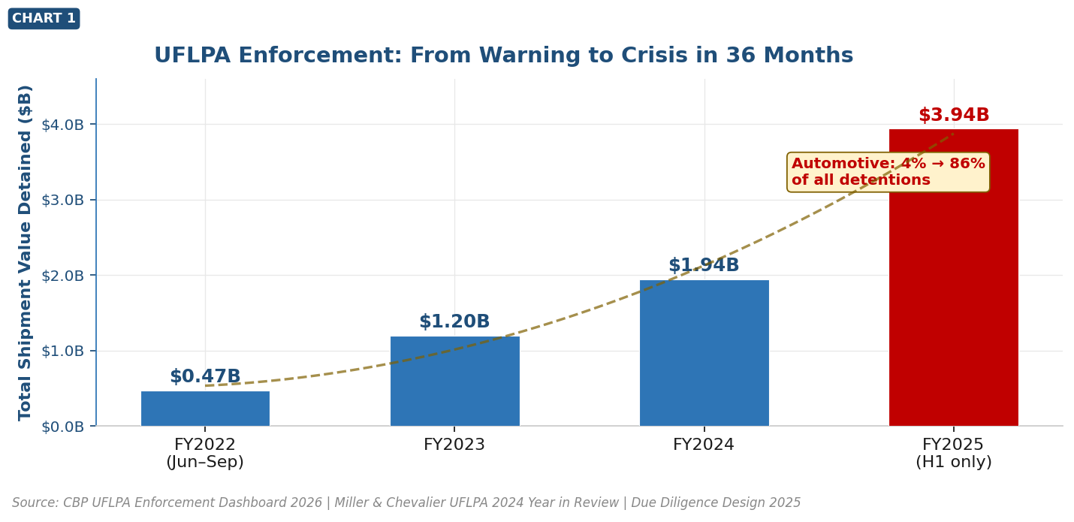

The automotive shift: In FY2024, automotive represented just 4% of UFLPA detentions. By H1 2025 that figure reached 86%. This is not a gradual trend — it is a step-change triggered by Entity List additions in December 2023 and subsequent congressional scrutiny of automotive OEM compliance.

1.2 US Import Tariff Revenue — The Scale of Enforcement

$195B  US customs duties collected FY2025  250% increase from FY2024 (CRFB confirmed) | $173B  Section 301 assessed duties on Chinese  imports through January 2023 alone | 250%+  Year-on-year increase in CBP collections  FY2024 to FY2025 — historic jump

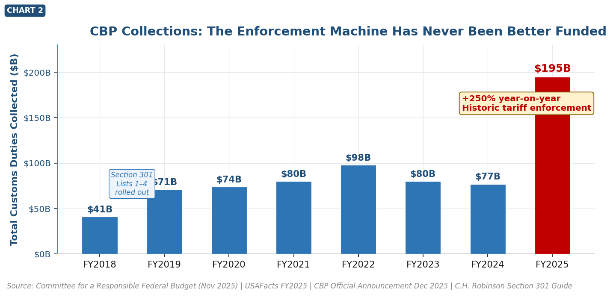

1.3 Corporate Financial Impact — Summary

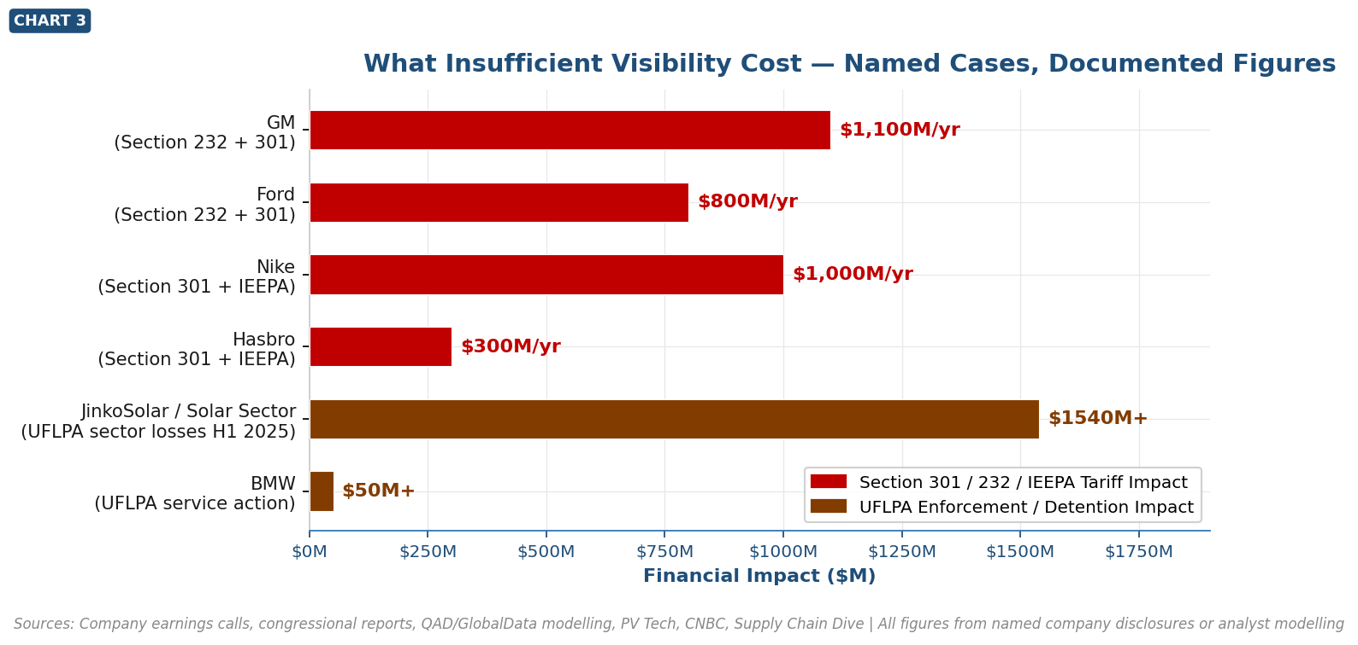

Sources: Company earnings calls, congressional reports, QAD/GlobalData modelling, PV Tech, CNBC, Supply Chain Dive. All figures from named company disclosures or analyst modelling.

Part 2 — The Case Studies: Six Incidents in Detail

Each case below answers four questions: why it happened, what it cost, what the company did to respond, and how ECC's material genealogy intelligence would have changed the outcome.

CASE  01 | Volkswagen Group — Porsche, Audi & Bentley  Automotive | UFLPA Enforcement — February 2024 | FINANCIAL IMPACT  Hundreds of millions  in delayed revenue

Why It Happened
US CBP impounded thousands of Volkswagen Group vehicles after a Tier-2 supplier notified Tier-1 supplier Lear Corp. that a LAN transformer subcomponent had been sourced from Sichuan Jingweida Technology Group (JWD) — added to the UFLPA Entity List in December 2023. Volkswagen had no visibility beyond Tier 1 and Tier 2. The violation was identified not by Volkswagen's internal systems, but by a supplier notification.

Congressional finding: 'Automakers' self-policing is clearly not doing the job.' — Senate Finance Committee Chair Ron Wyden, May 2024

Financial & Operational Impact
Vehicles impounded | Several thousand Audis, ~1,000 Porsches, several hundred Bentleys
Revenue at risk | At $80,000–$200,000+ average MSRP, hundreds of millions in delayed delivery revenue
Resolution timeline | Part replacement through end of March 2024 — 6+ weeks of delivery delays
Regulatory escalation | Congressional letter from House Select Committee on CCP demanding explanation
Reputational exposure | Coverage in FT, Reuters, BBC, CNBC; formal congressional inquiry

Immediate Response
- Voluntary disclosure to CBP upon being made aware
- Emergency replacement programme for banned LAN transformer across all impounded vehicles
- Suspension of deliveries of affected models until part replacement complete

How ECC Prevents This: ECC's material genealogy would have mapped the LAN transformer (L3 component) to its electronic subcomponent origin (L4-L5), flagging the JWD entity match before a single vehicle shipped. The fix would have been a sourcing switch — not an impoundment.

Source: Foley Hoag: CBP Enforcement Action Against Auto Industry https://foleyhoag.com/news-and-insights/publications/alerts/2024/february/cbp-begins-enforcement-action-against-auto-industry
Source: Resilinc: How One Volkswagen Part Led to Thousands of Impounded Cars https://resilinc.ai/blog/uflpa-compliance-volkswagen-china-part/

CASE  02 | BMW — 8,000 Mini Cooper UFLPA Violation  Automotive | UFLPA Enforcement — May 2024 | FINANCIAL IMPACT  $50M+ service action  + congressional report

Why It Happened
A US Senate Finance Committee investigation found BMW imported at least 8,000 Mini Cooper vehicles containing LAN transformer components from JWD — the same UFLPA-banned supplier. BMW received notification from Lear Corp. in January 2024 but continued importing until at least April 2024 — four months after JWD was blacklisted and three months after direct supplier notification. BMW lacked the internal tooling to rapidly identify, quarantine, and remediate specific BOM positions across its production volume.

Senate report finding: 'BMW continued to import products manufactured by JWD until at least April 2024.' — US Senate Finance Committee, May 2024

Financial & Operational Impact
Vehicles affected | At least 8,000 Mini Cooper cars imported with banned components
Service action cost | US-wide customer and dealer notification; component replacement across all 8,000 vehicles
Compliance liability | Each UFLPA-banned vehicle subject to detention — customs fines can reach the full shipment value
Congressional scrutiny | Named in Senate Finance Committee report; calls to 'supercharge enforcement'
Reputational damage | CNBC, BBC, Reuters, Financial Times coverage

Immediate Response
- Halted importation of affected products after Senate inquiry
- Initiated a service action — customer and dealer notification across all affected inventory
- Committed to auditing Lear and Bourns supply chains for further JWD exposure

How ECC Prevents This: ECC's graph would have flagged JWD (UFLPA Entity List) as a node match on the LAN transformer BOM position at L4-L5 with geo-political cascade risk scoring activated — before January 2024, not after a Senate investigation.

Source: CNBC: BMW imported 8,000 Mini Coopers with banned Chinese parts https://www.cnbc.com/2024/05/20/bmw-mini-cooper-banned-chinese-uflpa.html
Source: Miller & Chevalier: UFLPA Enforcement 2024 Year in Review https://www.millerchevalier.com/publication/trade-compliance-flash-uflpa-enforcement-2024-year-review

CASE  03 | Solar Industry — JinkoSolar, LONGi, Trina  Energy / Solar | UFLPA Mass Enforcement — 2022–2025 | FINANCIAL IMPACT  $700M detained Year 1  $1.54B sector losses H1 2025

Why It Happened
When UFLPA enforcement began June 2022, CBP immediately detained solar panel shipments from China's largest module manufacturers. The trigger: CBP required complete documentation proving polysilicon had no traceable link to Xinjiang — including raw quartzite sourcing documentation at the base of the manufacturing chain. The solar supply chain runs: quartzite → polysilicon → ingot → wafer → cell → module. CBP required documentation at the quartzite level — the L8 equivalent. The industry had zero L5–L8 material traceability.

Financial & Operational Impact
Direct detention value | ~$700M in modules detained in 2022 alone; over $3.5B total by end 2024
JinkoSolar US exports | Halved planned US exports in 2022 — self-excluding from a major market
Sector project delays | 'The most difficult renewable procurement environment of the past 15 years' — Silicon Ranch CEO
China top-4 solar losses | LONGi, JinkoSolar, Trina, JA Solar — combined net losses ~$1.54B in H1 2025
Federal raid | JinkoSolar's Jacksonville factory and California offices raided by DHS, FBI and CBP — May 2023

How ECC Prevents This: ECC's L8-level raw material mapping — quartzite → polysilicon → wafer → cell → module — with geographic origin tags at every node would have given these manufacturers a ready CBP compliance package. Instead of weeks of reactive documentation scramble, compliance is a pre-built export from the graph.

Source: Axios: Forced-labor crackdown hamstrings solar industry https://www.axios.com/pro/climate-deals/2023/01/09/forced-labor-crackdown-hamstrings-solar-industry
Source: PV Tech: China top-4 solar manufacturers — $1.54B losses H1 2025 https://www.pv-tech.org/chinas-top-four-solar-manufacturers-suffer-1-54-billion-losses-h1-2025/

CASE  04 | Nike — $1 Billion Annual Tariff Impact  Consumer / Apparel | Section 301 + IEEPA — FY2025 | FINANCIAL IMPACT  $1,000,000,000  annual cost increase

Why It Happened
Nike's CFO confirmed on a June 2025 earnings call that US tariffs would add an estimated $1 billion in annual incremental cost. China accounted for approximately 16% of Nike's US footwear imports. The effective tariff stack on Chinese-origin goods reached 58.3%. Gross margins declined 140 basis points. Nike had no BOM-level data to identify which product lines drove the highest exposure, which materials caused it, or which sourcing switches would yield the greatest saving per dollar spent. The response was broad and reactive.

Financial & Operational Impact
Annual tariff cost increase | $1 billion gross incremental cost — confirmed by Nike CFO on earnings call
Margin compression | Gross margin fell to 34.5% (Q3 2025) — 140 basis points below prior quarter
Market impact | Nike's market value dropped approximately one-third over the surrounding period
Consumer impact | 'Surgical price increases' on certain US products beginning fall 2025
Structural cost | Accelerated supply chain diversification from China — multi-year transition cost

Immediate Response
- Announced plan to cut China's share of US footwear imports from ~16% to high-single digits by end of FY2026
- Negotiated cost-sharing with suppliers and retail distribution partners
- Phased selective price increases beginning fall 2025
- Accelerated production diversification into Vietnam, Indonesia, Thailand

How ECC Prevents This: ECC's HTS code-level tariff scoring and BOM tariff rollup agent would have given Nike a ranked list of which product lines and specific material inputs carried the highest Section 301 exposure — before CFO guidance, not after. Sourcing shift decisions would be driven by the graph, not guesswork.

Source: Supply Chain Dive: Nike fights $1B tariff hit with sourcing shifts https://www.supplychaindive.com/news/nike-1b-tariff-sourcing-price-hikes/752159/
Source: Supply Chain Brain: Nike Faces $1B in Added Costs from Tariffs https://www.supplychainbrain.com/articles/42055-nike-faces-1b-in-added-costs-from-tariffs

CASE  05 | Hasbro — $100M–$300M Section 301 Exposure  Consumer Goods / Toys | Section 301 + IEEPA — 2025 | FINANCIAL IMPACT  $100M–$300M gross  ($200M uncertainty range)

Why It Happened
Hasbro CEO Chris Cocks disclosed in Q1 2025 earnings that US tariffs would create a gross impact of $100M to $300M across the enterprise before any mitigation. The $200M uncertainty range in a single guidance figure is the most important data point: it reflects the opacity of tariff exposure calculation across their product portfolio. Hasbro had no rapid mechanism to re-map exposure by SKU, material input, or manufacturing site as tariff rates escalated unpredictably between 50% and 145%.

Financial & Operational Impact
Gross tariff impact | $100M–$300M — a $200M uncertainty range reflecting poor supply chain tariff visibility
Strategic response | $1 billion cost savings plan accelerated partly to offset tariff pressure
Price increases | Price hikes confirmed as unavoidable — consumer demand risk
Employment risk | CEO warned of 'potential job losses as we adjust to absorb increased costs'
SKU migration | Hundreds of US-destined SKUs shifted from China to alternate countries

How ECC Prevents This: ECC's BOM tariff rollup agent computes HTS code-level tariff exposure per material node and aggregates to finished product — giving Hasbro a product-by-product tariff P&L before results season. The $200M uncertainty range collapses to a specific number with a specific list of SKUs to reprioritise.

Source: Supply Chain Dive: Hasbro shifting SKU origins away from China https://www.supplychaindive.com/news/hasbro-tariffs-china-manufacturing-move/746683/

CASE  06 | GM, Ford & Stellantis — Billion-Dollar Cost Increases  Automotive OEM | Section 232 + 301 + IEEPA — 2025 | FINANCIAL IMPACT  $1.1B / $0.8B / $0.5B  annual per OEM

Why It Happened
A 25% tariff on auto parts, Section 232 on steel and aluminum, Section 301 on Chinese components, and IEEPA reciprocal tariffs created cascading cost pressure across US automotive OEMs in 2025. In April 2025, China imposed export licence requirements on seven rare earth elements — all essential to NdFeB motor magnets used in EV traction motors. When China's export control landed, 'which of our assemblies are affected and by how much?' could not be answered from any existing system. Manual BOM review across thousands of components would take weeks.

Financial & Operational Impact
GM annual tariff impact | ~$1.1B annual cost increase from 25pp auto parts tariff (QAD/GlobalData modelling)
Ford annual tariff impact | ~$0.8B annual cost increase from same scenario
Stellantis annual tariff impact | ~$0.5B annual cost increase
Rare earth exposure | 7 elements under China export licence — critical to NdFeB magnets across all EV platforms
Semiconductor tariff (projected) | Section 301 semiconductor tariffs in June 2027 could add $1,100+ per vehicle (S&P Global)

How ECC Prevents This: ECC's NdFeB chain — bastnäsite → Nd oxide → Nd metal → NdFeB → motor magnet → traction motor — with geographic concentration scores at every node. When China's April 2025 export control dropped, ECC would have produced the assembly-level impact analysis and dollar-per-vehicle cost in a single graph traversal. No manual BOM review required.

Source: QAD Blog: Trump Tariffs — Implications for Automotive Supply Chains https://www.qad.com/blog/2025/06/the-status-of-trump-tariffs-implications-for-automotive-supply-chains
Source: CNBC: Trump's China tariff increase affects Ford and GM https://www.nbcphiladelphia.com/news/business/money-report/trumps-china-tariff-increase-affects-ford-and-gm-vehicles/4100650/

The Common Thread

Six incidents. Two regulatory mechanisms. Four sectors. One root cause.

In every case: the company knew its Tier-1 suppliers. It did not know what was inside those suppliers' products — at the material level, the HS code level, the origin level. ECC maps materials — not just suppliers. From finished assembly to raw ore. HS codes at every level. Geographic origin at every level. Tariff exposure calculated per BOM position. UFLPA entity flags traced to the specific component across every vehicle line simultaneously.

The question is not whether CBP will look deeper. They already are. Automotive went from 4% to 86% of UFLPA detentions in 12 months. CBP collected $195 billion in duties in FY2025 — 250% more than the year before. The enforcement machine is better funded, better targeted, and better equipped than at any point in US customs history. The question is whether your supply chain intelligence sees what CBP can see — before they do.

ECC / PMG Supply Chain Intelligence | Supplementary Research Document v3 — May 2026 | All financial figures from company disclosures, congressional reports, CBP data, or analyst modelling as cited

